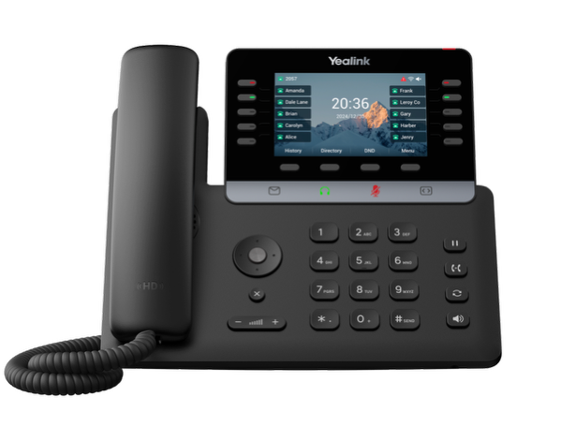 | Yealink® SIP-T74W Phone  The Yealink® SIP-T74W is a 10-line, Gigabit phone with built-in Bluetooth and Wifi and packed with many advanced features that will enhance your day-to-day business activities and make your life easier. This guide is designed to help you use some of the most popular features with your new Yealink® SIP-T74W phone.

Soft Keys  The soft keys located underneath the phone screen perform the functions that appear directly above them on the display. Their functions are context sensitive, which means the function of the soft keys change depending upon your current activity. For example, when conferencing, the soft keys display functions related to conferencing. The row of icons below the soft keys are touch-sensitive icon keys.  Line Keys  With the SIP-T74W, you can access up to 10 physical keys and up to 50 total virtual keys. The line keys, located to the left and right of the phone screen, indicate the status of your lines and associated activity. The LED informs you when a line is idle, ringing, in use or on hold. If you have more than 10 shared lines or BLFs assigned, touch the bottom right key on the touch sensitive row as this is a page selector allowing you to page through the additional key assignments.  Navigation Keys  The Navigation keys allow you to scroll through the options and lists on the display keys by pressing left, right, up or down. To select an item, press the OK button in the center of the navigation keys.  Answer a Call  To answer a call, simply pick up the handset or press the Answer soft key, Speakerphone key or the Headset touch-sensitive icon.  Place a Call  To place a call, simply pick up the handset or press the Speakerphone key or touch-sensitive headset icon, then dial the number. Calls can be placed by choosing a number from History or the Directory. |  | Feature Codes  *72 Call Forwarding Always Activation  *73 Call Forwarding Always Deactivation  *90 Call Forwarding Busy Activation  *91 Call Forwarding Busy Deactivation  *92 Call Forwarding No Answer Activation  *93 Call Forwarding No Answer Deactivation  *44 Call Recording (if enabled)  *67 Calling Line ID Delivery Blocking per Call  *65 Calling Line ID Delivery per Call  *68 Call Park  *88 Call Park Retrieve  *98 Call Pickup  *11 Call Retrieve  *69 Call Return  *70 Cancel Call Waiting  *99 Clear Voice Message Waiting Indicator  *55 Direct Voicemail Transfer  *78 Do Not Disturb Activation  *79 Do Not Disturb Deactivation  *62 Voice Portal Access  *66 Last Number Redial  Note: Some of these codes may not be available to all users. See your group admin to add features.

Other Features  Set up Voicemail  - Either press the Envelope icon and then press the Connect softkey, or Initiate a call.  - If calling, dial *62 or your extension.  - At the prompt, enter in a unique passcode, then press #.  - Re-enter your passcode, then press #.  - Follow instructions to record your name.  - Follow prompts to:  - Access voice mailbox  - Access greetings menu  - Change passcode  - Exit voice portal  Retrieve Voicemail Messages  A blinking red “message waiting” indicator light notifies you when you have a new voicemail message.  - To check your voicemail, press the Envelope icon on the touch-sensitive row below the softkeys.  - To use Visual Voicemail, press Enter and do the following:  - Use the Up/Down arrow keys to select a message, then press the Play softkey  - Press Delete to delete the message.  - Press Option to view details or place a call back.  - To call voicemail, press Connect and do the following:  - Enter your voicemail passcode if prompted, then press #. (If you forgot your passcode, please contact your system administrator.)  - Follow the audio prompts.  - Voicemail can also be reached by calling *62 or calling your extension. | Hold and Resume a Call  - To hold, press the Hold soft key or Hold hard key.  - To resume, press the Resume soft key or press the Hold hard key again.  Access Call Lists  - Call History can be accessed pressing the Up navigation key or pressing the History soft key.  - Use the left and right navigation keys to view All Calls, Placed Calls, Missed Calls or Received Calls.  - To dial a number, scroll to the desired number, then press the Call soft key or the Select button.  Do Not Disturb  - To enable Do Not Disturb, press the DND soft key.  - To disable, press the DND soft key again.  Make a Three-way Call  After the first call is connected:  - Press Conference softkey. The active call will be placed on hold.  - Dial the new party.  - When the call connects, press the Conference soft key again to join the calls.  Transfer a Call  - After the first call is connected:  - Press the Transfer hard key or soft key. (The active call will be placed on hold.)  - To transfer the call unannounced, enter the number and press the B Transfer soft key. (Blind Transfer)  - To speak to the transfer-to party first, Dial the number or extension and press Call.  - When the party answers, announce the transfer. Then press Transfer again to complete or hang up. If a Blind transfer, the call will transfer automatically.  To transfer the call directly to another user’s voicemail  - During the transfer process, Dial *55 plus the extension followed by #.  - A confirmation will announce the transfer is complete.

Call Forwarding
- Press the Menu soft key.
- Navigate to Features and press OK or the Enter softkey.
- Select Call Control and press OK or the Enter softkey.
- Use the up/down navigation keys to scroll to Call Forward and press OK or the Enter softkey.
- Choose from Always Forward, Busy Forward or No Answer Forward and press OK or the Enter softkey.
- Use the left/right navigation keys to turn an option on/off.
- Scroll down to each field and enter information, such as the Forward to number.
- Press the Save softkey to enable the forwarding option.
- To disable, follow the same steps and use the left/right navigation keys to toggle the call forward option off, then press the Save softkey to change your forwarding setting.
Shortcuts
- Pick up handset and dial:
  - *72 = Call Forwarding Always
  - *90 = Call Forwarding Busy
  - *92 = Call Forwarding No Answer
  - Enter destination number, then press #.
- To deactivate, dial:
  - *73 = Call Forwarding Always
  - *91 = Call Forwarding Busy
  - *93 = Call Forwarding No Answer

View a complete user guide at
https://support.yealink.com

