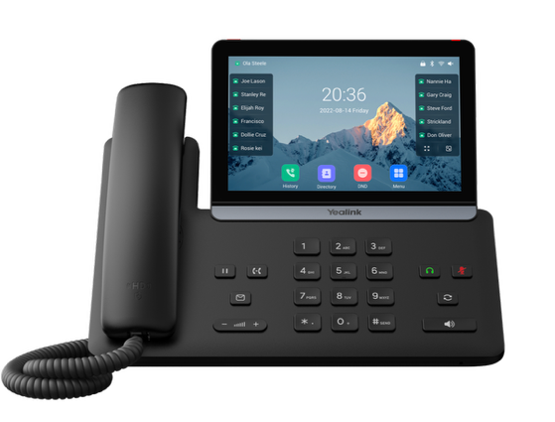 | Yealink® SIP-T87W Phone  The Yealink® SIP-T87W is a 28-line, touch screen, Gigabit phone with built-in Bluetooth and Wifi and packed with many advanced features that will enhance your day-to-day business activities and make your life easier. This guide is designed to help you use some of the most popular features with your new Yealink® SIP-T87W phone.

Soft Keys  The soft keys located along the bottom of the display perform the functions on their labels. Their functions are context sensitive, which means the function of the soft keys change depending upon your current activity. For example, when conferencing, the soft keys display functions related to conferencing.  Line Keys  With the SIP-T87W, you can access up to 28 line keys and up to 84 total virtual keys. The line keys, located to the left and right on the phone screen, indicate the status of your lines and associated activity. The icon informs you when a line is idle, ringing, in use or on hold. On the right-hand side of the display below the last line key are some grid view options. Touch the icon on the left to go to a full three-row grid view showing 28 line keys. Swipe left or right to go between the 3 pages of virtual line keys. Press the x at the top to go back to the normal view. Touch the right icon to get a clean view of your display with no line keys.  Navigation Keys  Navigation is performed by touching any on-screen icon, then using you finger to scroll up or down through any lists. To select an item, touch any entry in the list or touch an icon.  Answer a Call  To answer a call, simply pick up the handset or touch the Answer soft key, Speakerphone key or Headset key if you have a headset.  Place a Call  To place a call, simply pick up the handset, press the Speakerphone key or the Headset key, then dial the number. Calls can be placed by choosing a number from History or the Directory. |  | Feature Codes  *72 Call Forwarding Always Activation  *73 Call Forwarding Always Deactivation  *90 Call Forwarding Busy Activation  *91 Call Forwarding Busy Deactivation  *92 Call Forwarding No Answer Activation  *93 Call Forwarding No Answer Deactivation  *44 Call Recording (if enabled)  *67 Calling Line ID Delivery Blocking per Call  *65 Calling Line ID Delivery per Call  *68 Call Park  *88 Call Park Retrieve  *98 Call Pickup  *11 Call Retrieve  *69 Call Return  *70 Cancel Call Waiting  *99 Clear Voice Message Waiting Indicator  *55 Direct Voicemail Transfer  *78 Do Not Disturb Activation  *79 Do Not Disturb Deactivation  *62 Voice Portal Access  *66 Last Number Redial  Note: Some of these codes may not be available to all users. See your group admin to add features.

Other Features  Set up Voicemail  - Press the Messages key, then press the Messages key again to call voicemail, or call your extension.  - At the prompt, enter in a unique passcode, then press #.  - Re-enter your passcode, then press #.  - Follow instructions to record your name.  - Follow prompts to:  - Access voice mailbox  - Access greetings menu  - Change passcode  - Exit voice portal  Retrieve Voicemail Messages  A blinking red “message waiting” indicator light notifies you when you have a new voicemail message.  - To check your voicemail, press the Messages key.  - To use Visual Voicemail:  - Touch the entry for your extension from the list.  - Touch the screen and drag your finger up or down through the list of voicemails, then touch the message you want to play.  - Touch Delete to delete the message.  - Touch Option to view details or place a call back.  - To call voicemail, call *62 or your extension or press the Messages key twice and do the following:  - Enter your voicemail passcode if prompted, then press #. (If you forgot your passcode, please contact your system administrator.)  - Follow the audio prompts.  Hold and Resume a Call  - To hold, touch the Hold soft key or Hold hard key.  - To resume, touch the Resume soft key or press the Hold hard key again. | Access Call Lists  - Call History can be accessed by touching the History soft key.  - On the left, touch whether to view Network Calls or the subset of Placed Calls, Missed Calls or Received Calls.  - To view information about the call, touch the “i” icon to the right of the entry.  - To dial a number, scroll to the desired entry, then touch the entry.  Do Not Disturb  - To enable Do Not Disturb, touch the DND soft key.  - To disable, touch the DND soft key again.  Make a Three-way Call  After the first call is connected:  - Touch the Conference softkey. The active call will be placed on hold.  - Dial the new party and touch Conference on the right.  - When the call connects, touch the Conference soft key again to join the calls.  Transfer a Call  - After the first call is connected:  - Touch the Transfer soft key or press the hard key. (The active call will be placed on hold.)  - To transfer the call unannounced, enter the number and touch the B Transfer soft key (Blind Transfer).  - To speak to the transfer-to party first, Dial the number or extension and touch Call.  - When the party answers, announce the transfer. Then touch Transfer again to complete or hang up. If a Blind transfer, the call will transfer automatically.  To transfer the call directly to another user’s voicemail  - During the transfer process, Dial *55 plus the extension followed by #.  - A confirmation will announce the transfer is complete.

Call Forwarding
- Touch the Menu soft key.
- Touch the Features icon.
- In the right-hand list, use your finger to scroll to the Call Forward feature and touch that entry.
- Choose from Always Forward, Busy Forward or No Answer Forward and touch that entry.
- Use the touch screen to enable options by touching the slider to turn on/off the feature.
- Touch each field and enter information, such as the Forward to number using the on-screen keyboard, then touch the enter soft key on the right-hand side of the on-screen keyboard to complete your entry.
- Touch the Save softkey to enable the forwarding option.
- To disable, follow the same steps and move the slider to the off position to toggle the call forward option off, then touch the Save softkey to change your forwarding setting.
Shortcuts
- Pick up handset and dial:
  - *72 = Call Forwarding Always
  - *90 = Call Forwarding Busy
  - *92 = Call Forwarding No Answer
  - Enter destination number, then press #.
- To deactivate, dial:
  - *73 = Call Forwarding Always
  - *91 = Call Forwarding Busy
  - *93 = Call Forwarding No Answer

View a complete user guide at
https://support.yealink.com

